Experiment 5: Solving the 8-Queens Problem Using Backtracking
AIM: To find the collision-free placement of components on a grid.
QUESTION:
An automated placement system must position eight components on an 8 × 8 grid such that no two components interfere with one another. Model this as the 8-Queens problem, where each queen represents a component and can attack another queen along the same row, column, or diagonal.
Develop a Python program using the backtracking algorithm to find a valid arrangement of eight queens on the chessboard.
The program must:
- Represent the chessboard as an 8 × 8 grid and track the positions of the queens.
- Place one queen at a time while ensuring that no two queens share the same row, column, or diagonal.
- Use recursive backtracking to undo an invalid placement and explore alternative positions.
- Display the final chessboard arrangement and the positions of all eight queens.
- Report the number of placement attempts and explain how constraint checking and backtracking help find a valid solution.
Program
N = 8
# Create an 8 x 8 chessboard
board = [[0 for _ in range(N)] for _ in range(N)]

# Store the column position of each queen
positions = []

# Count placement attempts
attempts = 0

def is_safe(row, col):
# Check the same column in previous rows
for i in range(row):
if board[i][col] == 1:
return False

# Check upper-left diagonal
i, j = row - 1, col - 1
while i >= 0 and j >= 0:
if board[i][j] == 1:
return False
i -= 1
j -= 1

# Check upper-right diagonal
i, j = row - 1, col + 1
while i >= 0 and j < N:
if board[i][j] == 1:
return False
i -= 1
j += 1

return True

def solve(row):
global attempts

# All eight queens have been placed
if row == N:
return True

# Try placing a queen in each column
for col in range(N):
attempts += 1

if is_safe(row, col):
# Place the queen
board[row][col] = 1
positions.append((row + 1, col + 1))

# Solve the next row recursively
if solve(row + 1):
return True

# Backtrack: remove the queen
board[row][col] = 0
positions.pop()

return False

# Execute the algorithm
if solve(0):
print("Valid 8-Queens Solution:\n")

# Display the chessboard
for row in board:
print(" ".join("Q" if cell == 1 else "." for cell in row))

print("\nQueen Positions (Row, Column):")
for position in positions:
print(position)

print("\nTotal placement attempts:", attempts)
else:
print("No solution exists.")

Output
Valid 8-Queens Solution:
Q . . . . . . .
. . . . Q . . .
. . . . . . . Q
. . . . . Q . .
. . Q . . . . .
. . . . . . Q .
. Q . . . . . .
. . . Q . . . .

Queen Positions (Row, Column):
(1, 1)
(2, 5)
(3, 8)
(4, 6)
(5, 3)
(6, 7)
(7, 2)
(8, 4)

Total placement attempts: 876
Experiment 6: Solving the Map Colouring Problem Using CSP
AIM: To make frequency allocation for neighbouring cellular network regions.
QUESTION:
A telecommunications network is divided into interconnected regions. To reduce interference, neighbouring regions must be assigned different frequency bands. Model the network as a Constraint Satisfaction Problem (CSP), where each region is a variable, the available frequency bands form its domain, and neighbouring regions must receive different assignments.
Develop a Python program to solve the map-colouring problem using CSP techniques.
The program must:
- Represent each region as a variable and define its available colours as a domain.
- Specify adjacency constraints requiring neighbouring regions to have different colours.
- Use backtracking search to find a valid colour assignment.
- Display the final map-colouring assignment and verify that all adjacency constraints are satisfied.
- Report the number of assignments attempted and explain how CSP variables, domains, and constraints guide the search.
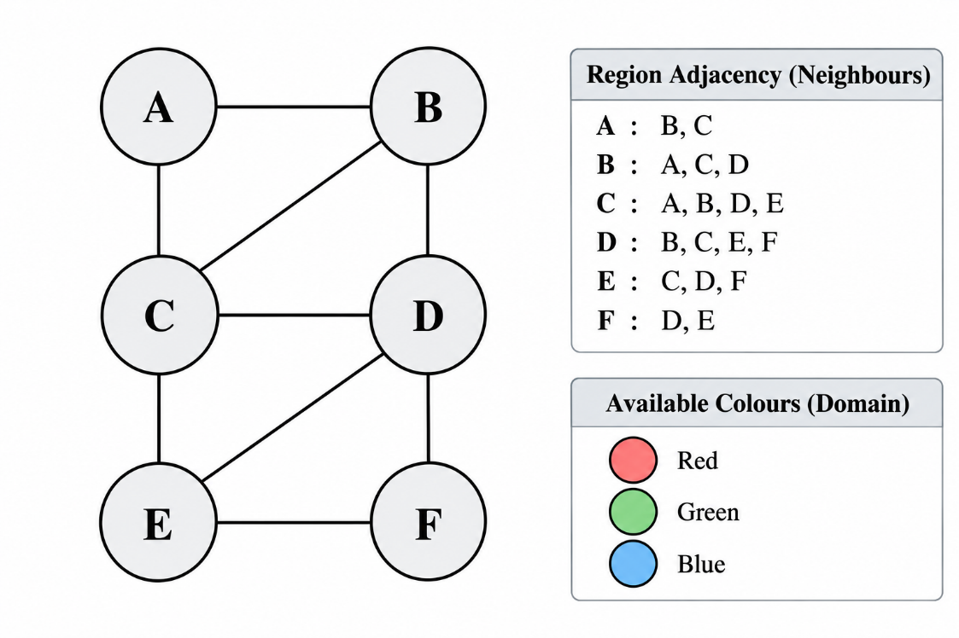

Program

# Available colours (domains)
colours = ["Red", "Green", "Blue"]

# Variables: regions A, B, C, D, E, F
regions = ["A", "B", "C", "D", "E", "F"]

# Adjacency constraints from the given diagram
neighbours = {
"A": ["B", "C"],
"B": ["A", "C", "D"],
"C": ["A", "B", "D", "E"],
"D": ["B", "C", "E", "F"],
"E": ["C", "D", "F"],
"F": ["D", "E"]
}

# Store the assigned colours
assignment = {}

# Count assignment attempts
attempts = 0

def is_safe(region, colour):
# Check whether any already-coloured neighbour
# has the same colour
for neighbour in neighbours[region]:
if assignment.get(neighbour) == colour:
return False

return True

def solve(index):
global attempts

# All regions have been coloured
if index == len(regions):
return True

# Select the next region
region = regions[index]

# Try each available colour
for colour in colours:
attempts += 1

if is_safe(region, colour):
# Assign the colour
assignment[region] = colour

# Solve for the next region
if solve(index + 1):
return True

# Backtrack: remove the colour assignment
del assignment[region]

return False

# Run the CSP solver
if solve(0):
print("Valid Map Colouring:\n")

for region in regions:
print(region, ":", assignment[region])

# Verify all adjacency constraints
valid = True

for region in regions:
for neighbour in neighbours[region]:
if assignment[region] == assignment[neighbour]:
valid = False
print("Conflict:", region, "and", neighbour)

print("\nAll adjacency constraints satisfied:", valid)
print("Total assignment attempts:", attempts)

else:
print("No valid colouring exists.")

Output
Valid Map Colouring:
A : Red
B : Green
C : Blue
D : Red
E : Green
F : Blue

All adjacency constraints satisfied: True
Total assignment attempts: 12

Experiment 7 - Implementing the Minimax Algorithm
AIM: To demonstrate decision-making in a two-player strategy game.
QUESTION:
A game-playing AI must select its best move in a two-player game where one player tries to maximize the score while the opponent tries to minimize it.
Develop a Python program to implement the Minimax algorithm for a game represented as a binary game tree. The program must:
- Represent the game tree with terminal utility values.
- Treat the AI as the maximizing player and the opponent as the minimizing player.
- Recursively evaluate the game tree using the Minimax algorithm.
- Display the evaluated values and the best move selected by the AI.
- Explain how the algorithm assumes that both players choose optimal moves.

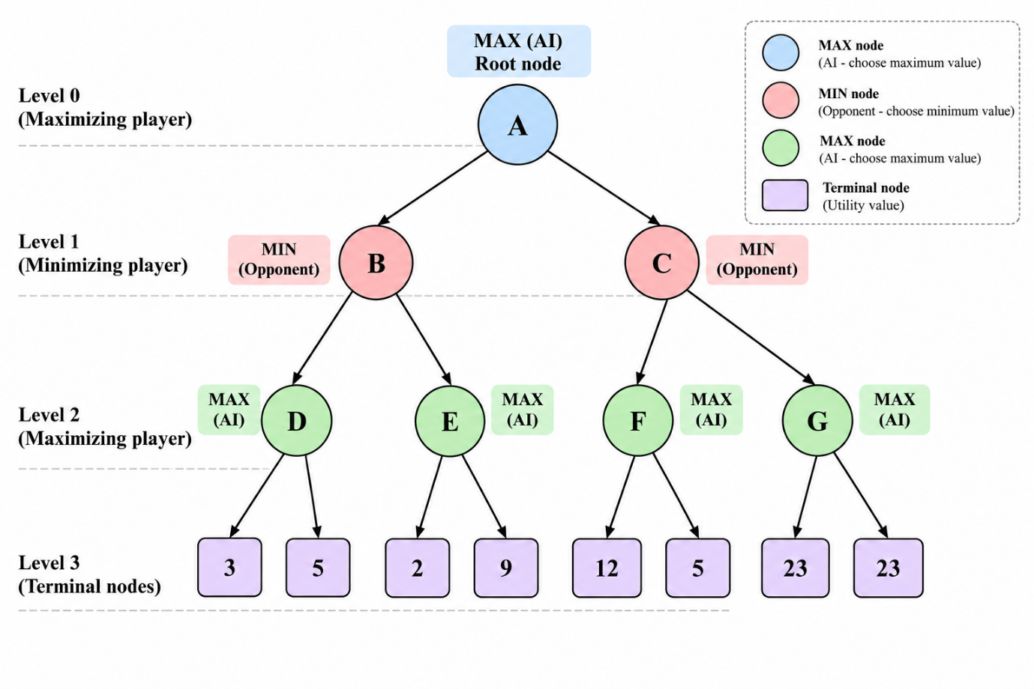
Program
# Game tree based on the given diagram
tree = {
"A": ["B", "C"],
"B": ["D", "E"],
"C": ["F", "G"],
"D": [3, 5],
"E": [2, 9],
"F": [12, 5],
"G": [23, 23]
}

# Store the evaluated value of each node
values = {}

def minimax(node, is_maximizing):
# If the node is a terminal node, return its utility
if isinstance(node, int):
return node

# Evaluate all children recursively
child_values = []

for child in tree[node]:
value = minimax(child, not is_maximizing)
child_values.append(value)

# MAX chooses the largest value
if is_maximizing:
best_value = max(child_values)
else:
# MIN chooses the smallest value
best_value = min(child_values)

values[node] = best_value
return best_value

# Start from root node A (MAX)
best_value = minimax("A", True)

print("Minimax Evaluation:")
for node in ["D", "E", "F", "G", "B", "C", "A"]:
print(node, "=", values[node])

print("\nBest move for AI:", tree["A"][
0 if values["B"] >= values["C"] else 1
])
print("Best achievable utility:", best_value)

Output
Minimax Evaluation:
D = 5
E = 9
F = 12
G = 23
B = 5
C = 12
A = 12
Best move for AI: C
Best achievable utility: 12

Experiment 8 - Implementing Alpha-Beta Pruning
AIM: To optimize decision-making in a two-player strategy game.
QUESTION:
A chess-playing AI evaluates possible moves by exploring a game tree. Since evaluating every possible move is computationally expensive, the AI uses Alpha-Beta Pruning to eliminate branches that cannot influence the final decision.
Develop a Python program to implement the Alpha-Beta Pruning algorithm for a chess-inspired game tree with multiple possible moves and terminal utility values.
The program must:
- Represent the game tree with multiple candidate moves and terminal utility values.
- Implement Alpha-Beta Pruning using alpha and beta bounds.
- Identify and skip branches that cannot affect the final decision.
- Display the selected move, its utility value, the number of nodes evaluated, and the number of branches pruned.
- Explain how Alpha-Beta Pruning reduces the search effort while preserving the optimal decision.

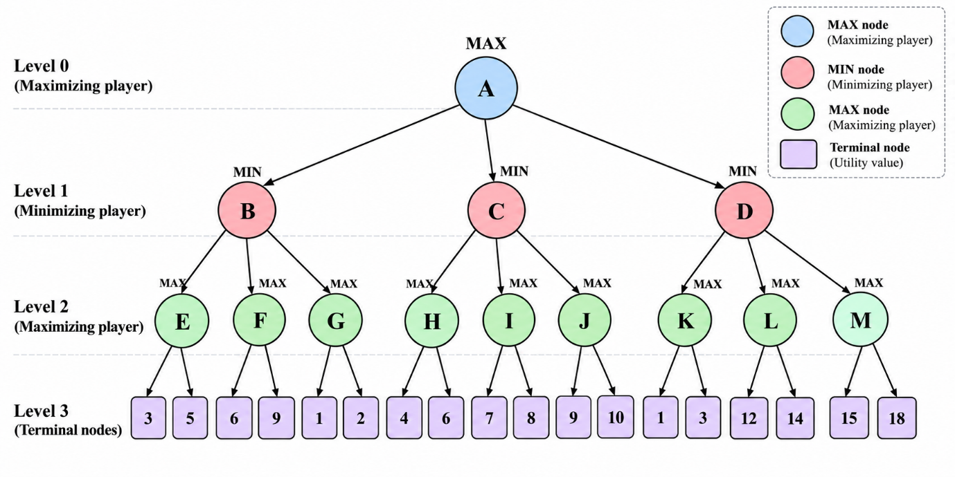

Program
# Game tree based on the given diagram
tree = {
"A": ["B", "C", "D"],
"B": ["E", "F", "G"],
"C": ["H", "I", "J"],
"D": ["K", "L", "M"],
"E": [3, 5],
"F": [6, 9],
"G": [1, 2],
"H": [4, 6],
"I": [7, 8],
"J": [9, 10],
"K": [1, 3],
"L": [12, 14],
"M": [15, 18]
}

# Count evaluated terminal nodes and pruned branches
nodes_evaluated = 0
branches_pruned = 0

def alpha_beta(node, alpha, beta, is_max):
global nodes_evaluated, branches_pruned

# Terminal node: return its utility value
if isinstance(node, int):
nodes_evaluated += 1
return node

if is_max:
best_value = float("-inf")

for i, child in enumerate(tree[node]):
value = alpha_beta(child, alpha, beta, False)
best_value = max(best_value, value)
alpha = max(alpha, best_value)

# Prune remaining branches if alpha >= beta
if alpha >= beta:
branches_pruned += len(tree[node]) - i - 1
break

return best_value

else:
best_value = float("inf")

for i, child in enumerate(tree[node]):
value = alpha_beta(child, alpha, beta, True)
best_value = min(best_value, value)
beta = min(beta, best_value)

# Prune remaining branches if beta <= alpha
if beta <= alpha:
branches_pruned += len(tree[node]) - i - 1
break

return best_value

# Evaluate each candidate move from the root
move_values = {}

for move in tree["A"]:
move_values[move] = alpha_beta(
move, float("-inf"), float("inf"), False
)

# Select the best move for MAX
best_move = max(move_values, key=move_values.get)
best_value = move_values[best_move]

print("Move evaluations:")
for move, value in move_values.items():
print(move, "=", value)

print("\nBest move for AI:", best_move)
print("Best utility value:", best_value)
print("Terminal nodes evaluated:", nodes_evaluated)
print("Branches pruned:", branches_pruned)

Output
Move evaluations:
B = 2
C = 6
D = 3

Best move for AI: C
Best utility value: 6
Terminal nodes evaluated: 13
Branches pruned: 5

